Saran

* Multi Comment

Pertanyaan

* Mengambil string mulai dari belakang
* slide 46

String Operations

* upper
* replace
* find

Things to read

<https://www.youtube.com/githubguides>

https://guides.github.com/

**Sesi 2**

List

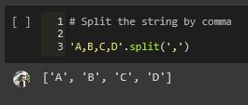

tupples

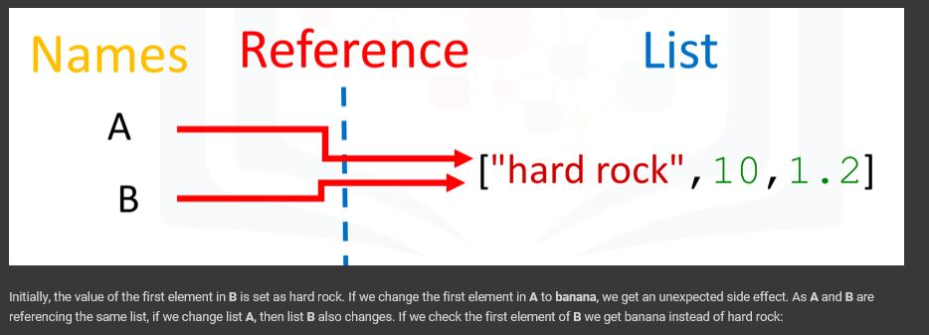

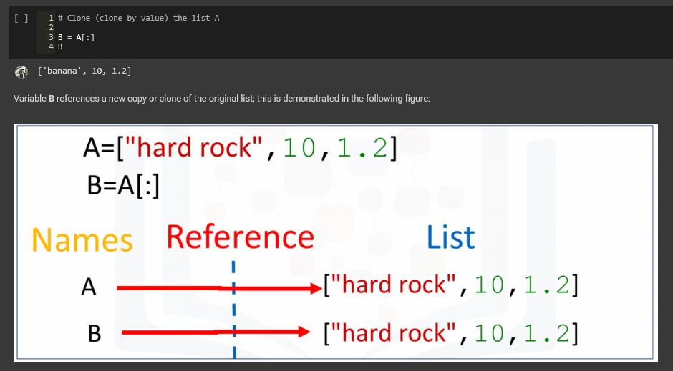

Set

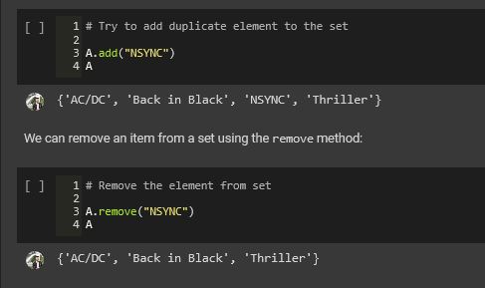

Set Operations

* Union
* Difference
* Intersection
* issubset
* issuperset

